**تکلیف دوم(عملی) درس کامپایلر**

**مسیح تنورساز(40006133)**

**بخش اول:**

|  |  |  |
| --- | --- | --- |
| **RULE/FF** | **FIRST()** | **FOLLOW()** |
| **StatementList** | **[id, while, if, ε]** | **[$, }]** |
| **Statement** | **[if, while, id]** | **[if, while, id, $, }]** |
| **Assignment** | **[id]** | **[if, while, id, $, }]** |
| **Conditional** | **[if]** | **[if, while, id, $, }]** |
| **Loop** | **[while]** | **[if, while, id, $, }]** |
| **Expr** | **[id, number]** | **[;, )]** |
| **RestExpr** | **[+, ε]** | **[;, )]** |
| **Factor** | **[id, number]** | **[+, ;, )]** |

**بخش سوم:**

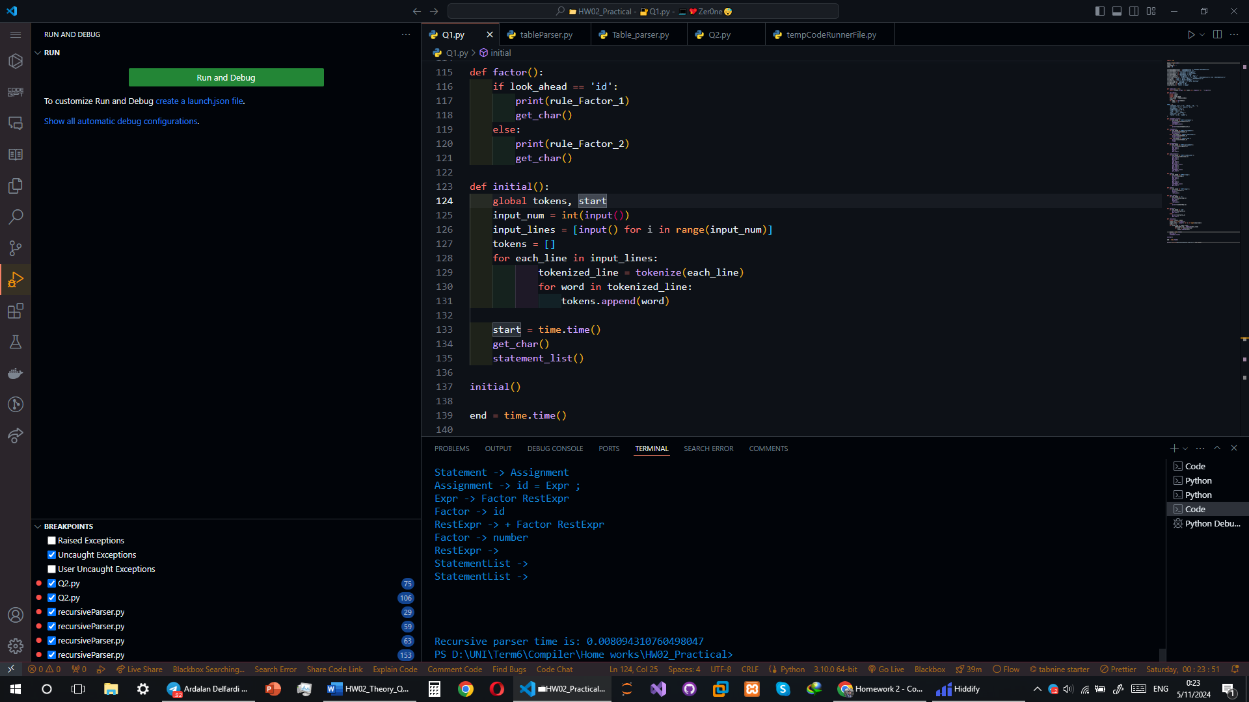

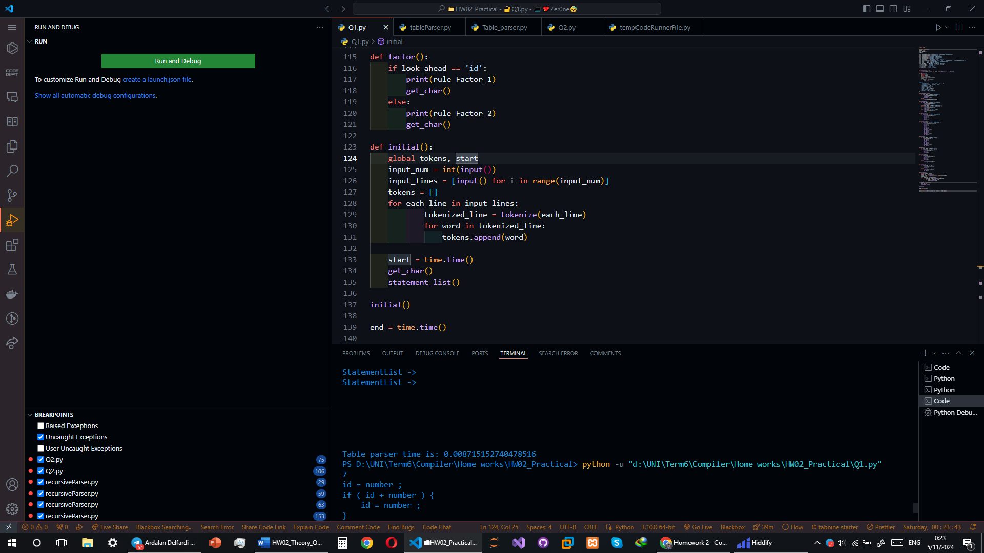

**بخش دوم:**

rule_StatementList_1 = "StatementList -> Statement StatementList"

rule_StatementList_2 = "StatementList ->"

rule_Statement_1 = "Statement -> Assignment"

rule_Statement_2 = "Statement -> Conditional"

rule_Statement_3 = "Statement -> Loop"

rule_Assignment_1 = "Assignment -> id = Expr ;"

rule_Conditional_1 = "Conditional -> if ( Expr ) { StatementList } else { StatementList }"

rule_Loop_1 = "Loop -> while ( Expr ) { StatementList }"

rule_Expr_1 = "Expr -> Factor RestExpr"

rule_RestExpr_1 = "RestExpr -> + Factor RestExpr"

rule_RestExpr_2 = "RestExpr ->"

rule_Factor_1 = "Factor -> id"

rule_Factor_2 = "Factor -> number"

|  |  |  |  |  |  |  |  |  |  |  |  |  |  |
| --- | --- | --- | --- | --- | --- | --- | --- | --- | --- | --- | --- | --- | --- |
|  | **Id** | **=** | **;** | **(** | **)** | **{** | **}** | **+** | **Number** | **If** | **Else** | **While** | **$** |
| **StatementList** | **rule_StatementList_1** |  |  |  |  |  | **rule_StatementList_2** |  |  | **rule_StatementList_1** |  | **rule_StatementList_1** | **rule_StatementList_2** |
| **Statement** | **rule_Statement_1** |  |  |  |  |  |  |  |  | **rule_Statement_2** |  | **rule_Statement_3** |  |
| **Assignment** | **rule_Assignment_1** |  |  |  |  |  |  |  |  |  |  |  |  |
| **Conditional** |  |  |  |  |  |  |  |  |  | **rule_Conditional_1** |  |  |  |
| **Loop** |  |  |  |  |  |  |  |  |  |  |  | **rule_Loop_1** |  |
| **Expr** | **rule_Expr_1** |  |  |  |  |  |  |  | **rule_Expr_1** |  |  |  |  |
| **RestExpr** |  |  | **rule_RestExpr_2** |  | **rule_RestExpr_2** |  |  | **rule_RestExpr_1** |  |  |  |  |  |
| **Factor** | **rule_Factor_1** |  |  |  |  |  |  |  | **rule_Factor_2** |  |  |  |  |